An

Industrial Training Report on

# Front End Web Development

At

**Bussibees Ed-tech Pvt Ltd**

*Submitted in partial fulfillment of the requirements for* *the award of the degree of*

## Bachelor of Technology in

**Information Technology**



**(Session 2024-25)**

**Submitted to:** **Submitted by:**

**Ms. Priya Shekhawat Joyesh Santra**

**Mr. Alok Singh PCE23IT025**

**(Faculty Coordinator)**  **a**

# DEPARTMENT OF Information Technology POORNIMA COLLEGE OF ENGINEERING, JAIPUR RAJASTHAN TECHNICAL UNIVERSITY, KOTA

1 | P a g e

## DECLARATION

I hereby declare that the work which is being presented in the **Industrial Training** report titled Front-End Web Development in partial fulfillment for the award of the Degree of **Bachelor of Technology** in **Information Technology** and submitted to the Department of **Information Technology**, **Poornima College of Engineering, Jaipur**, is an authentic record of my own work carried out at **Bussibees Ed-tech Pvt Ltd**, Jaipur during the session 2024-25 (Odd Semester).

I have not submitted the matter presented in this report anywhere for the award of any other Degree.

Signature of the Student:

Name: Joyesh Santra

Reg. No.: PCE23IT025

Place: Jaipur

Date: 23/08/2024

**Training Certificate from Company:**

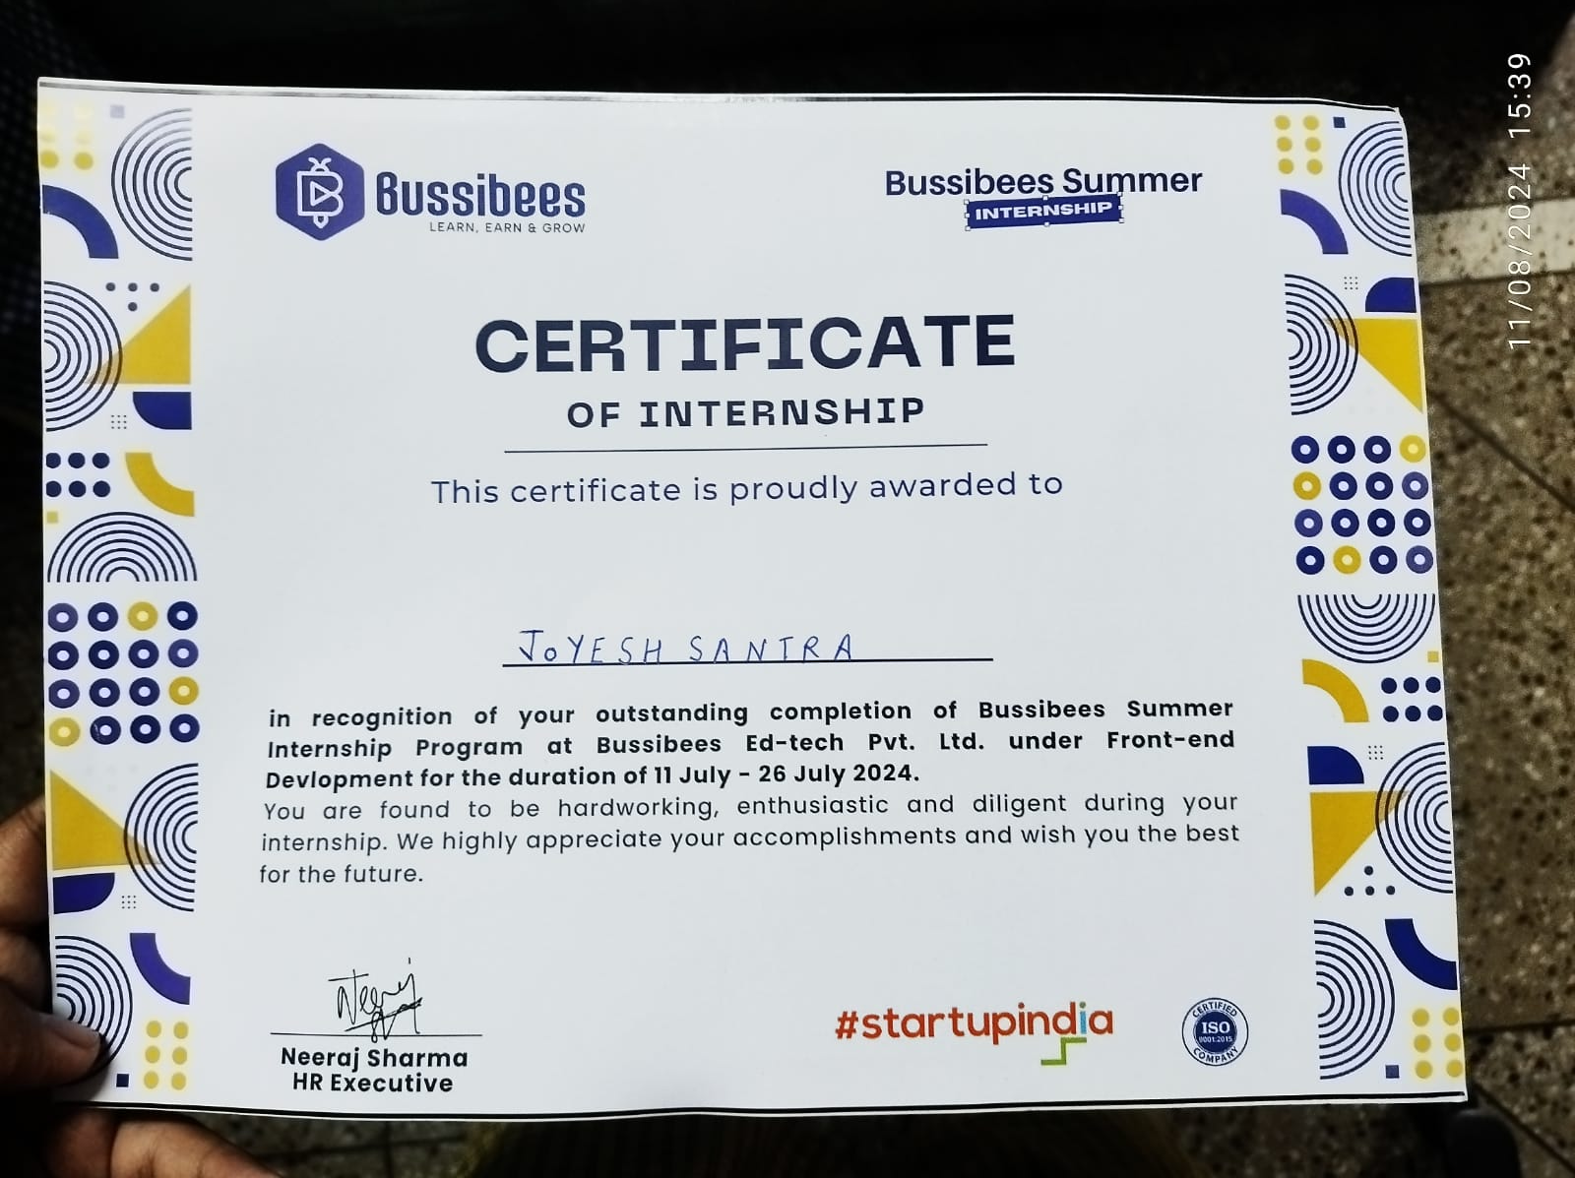



## DEPARTMENT OF COMPUTER ENGINEERING

**Date: 23/08/2024**

# CERTIFICATE

This is to certify that Industrial Training report on **Front End Web Development** has been submitted by **Joyesh Santra**, **PCE23IT025** in partial fulfillment for the award of the Degree of Bachelor of Technology in Information Technology during the session 202-25. The industrial training work is found satisfactory and approved for submission.

**Ms.Priya Shekhawat (Dr. Gajendra Singh Rajawat)**

Mr. Alok Singh HOD,IT

(Faculty Coordinators-Industrial Training Seminar)

## ACKNOWLEDGEMENT

I want to express my deep respect and appreciation to my supervisor Mr. Neeraj Sharma,

who is the HR and Manager of Bussibees Ed-tech Pvt Ltd, for his dedicated support,

guidance, and encouragement during my internship.

I want to express my sincere thanks to Mr. Shiryansh Sharma, Coordinator - Industrial

Training, for his cooperation in guiding the topic to its successful conclusion.

I want to express my deep appreciation to Dr. Gajendra Singh Rajawat, who is the Head

of the Information Technology Department at Poornima College of Engineering, for

consistently supporting, guiding, and motivating me throughout this research project.

I appreciate Dr. Mahesh Bundele, Director of Poornima College of Engineering, for his

helpful attitude and dedication to completing this training work on schedule.

I wish to extend my heartfelt thanks to the leadership of Poornima College of Engineering,

which includes Ar. Rahul Singhi, Director of Poornima Group, supports the

establishment of the institute and the provision of facilities for my education.

I am immensely grateful to my parents and all my other family members for their blessings and motivation. Finally, I want to express my gratitude to God for allowing me to finish my training on schedule.

**Joyesh Santra**

**PCE23IT025**

**TABLE OF CONTENTS**

|  |  |  |
| --- | --- | --- |
| **S.no.** | **PARTICULARS** | **Page No.** |
| 1 | Title Page | 1 |
| 2 | Candidate’s Declaration | 2 |
| 3 | Training Certificate from Company | 3 |
| 4 | Certificate by the Department | 4 |
| 5 | Acknowledgment | 5 |
| 6 | Table of Contents | 6 |
| 7 | Abstract | 7 |
| 8 | Chapter 1: Introduction | 8 |
| 9 | Chapter 2: Technical Training Platform | 9 |
| 10 | Chapter 3: Training Introduction | 11 |
| 11 | Chapter 4: Project Development | 13 |
| 12 | Chapter 5:Conclusion | 20 |
| 13 | References | 22 |

ABSTRACT

During my internship at Bussibees Ed-Tech Pvt. Ltd., I worked as a front-end developer,

gaining practical experience in creating and enhancing the user interface (UI) of web

applications. My primary responsibilities involved translating design concepts into

functional and visually appealing web pages, ensuring that the end product was both user-

friendly and efficient.

Throughout the internship, I utilized various front-end technologies to build responsive

and interactive web applications, including:

HTML (HyperText Markup Language): I used HTML to structure the content and

layout of web pages, ensuring they were well-organized and accessible.

CSS (Cascading Style Sheets): CSS was employed to style and format web pages,

enabling the creation of visually consistent and aesthetically pleasing designs, including

colour schemes, typography, and layout adjustments.

Additionally, I collaborated with back-end developers to integrate front-end designs with

server-side functionalities, ensuring a cohesive and smooth performance across the web

applications. This internship provided me with valuable hands-on experience in front-end

web development, equipping me with the skills and knowledge necessary to contribute

effectively to future projects.

CHAPTER 1 INTRODUCTION

1.1 About Company:

My name is Joyesh Santra, and I am currently pursuing a Bachelor of Technology in

Information Technology from Poornima College of Engineering, Jaipur. I am a resident

of Jaipur, Rajasthan. I have a strong passion for technology and web development, which

led me to undertake an internship in front-end web development at Bussibees Ed-Tech

Pvt. Ltd. This experience has significantly enhanced my technical skills and provided

valuable insights into the practical aspects of software development.

1.2 Training Course: Front End Web Development

1.3 Training Platform: Bussibees Ed-tech Pvt Ltd

1.4 Training Starting Date: 11 July 2024

1.5 Training Ending Date: 26 July 2024

1.6 Total Training Duration: 2 Weeks

1.7 Date of Certification: 07 August 2024

1.8 Conclusion:

In conclusion, my internship at Bussibees Ed-Tech Pvt. Ltd. provided me with the

opportunity to contribute to an innovative education technology company that is at the

forefront of transforming digital learning. Over the course of two weeks, I gained hands-

on experience in front-end web development, applying my skills to support the company's

mission of delivering impactful and scalable digital solutions.

CHAPTER 2 TECHNICAL TRAINING PLATFORM

2.1 Introduction:

The internship I was assigned to was at Bussibees Ed-Tech Pvt. Ltd., which is the chosen

Technical Training Platform. A top education technology firm devoted to creating

advanced digital solutions for education sector. The platform offered in-depth training in

front-end web development concentrating on fundamental technologies like HTML, CSS,

and JavaScript. This training was created with the intention. The goal is to provide interns

with the essential skills needed to create, build, and execute user-friendly, visually

appealing designs.

2.2 Reason for selecting this platform:

The selection of Bussibees Ed-tech Pvt. Ltd.'s training platform was primarily driven by

its alignment with industry standards and best practices in front-end development. The

platform offered a comprehensive curriculum, hands-on exercises, and real-world project

opportunities, making it an ideal choice for developing practical skills. Additionally, the

company's reputation as a pioneer in the Ed-tech industry contributed to its selection as a

preferred training provider.

2.3 Profile of University/Organization Providing the Course:

Bussibees Ed-Tech Pvt. Ltd. is a pioneering company in the education technology

industry, known for its dedication to transforming the learning experience through

advanced digital platforms. The company offers a range of services and tools designed to

empower educational institutions and businesses, providing them with scalable and

impactful solutions.

2.4 Technical Profile of the Instructor:

The Instructor/Trainer was Mr. Shiryansh Sharma. He is an experienced front-end

developer with a strong command of HTML, CSS, and JavaScript. His extensive industry

experience includes working on diverse web development projects that showcase his

technical expertise and creative problem-solving skills. Known for his ability to convey

complex concepts clearly, he significantly enhanced the learning experience, providing

practical insights into front-end development best practices.

2.5 Conclusion:

The training platform provided by Bussibees Ed-tech Pvt. Ltd. offered a robust foundation

in front-end web development. The alignment of the curriculum with industry trends and

the practical nature of the training contributed significantly to the development of

essential skills. The platform's focus on hands-on experience and real-world projects

facilitated the application of theoretical knowledge in a practical setting.

## CHAPTER 3 TRAINING INTRODUCTION

## 3.1 Introduction:

## During my internship at Bussibees Ed-Tech Pvt. Ltd., I had the opportunity to immerse

## myself in the field of front-end web development. The training provided a solid

## foundation in essential front-end technologies, focusing on HTML, CSS, and JavaScript.

## Through hands-on experience and real-world projects, I was able to develop my skills in

## creating responsive, user-friendly, and visually appealing web interfaces. This chapter

## outlines the technologies I worked with, the level of exposure I gained, and the overall

## impact of the training on my professional development.

## 3.2 Technology Description:

## • HTML (HyperText Markup Language): The backbone of web development, HTML

## was used to structure the content and layout of web pages. I learned how to create

## well-organized, semantically meaningful documents that form the basis of any

## website.

## • CSS (Cascading Style Sheets): CSS was used to control the appearance and formatting

## of web pages. I gained experience in designing visually appealing and consistent

## layouts, managing colour schemes, fonts, and spacing to enhance the user experience.

## • JavaScript: JavaScript was the key technology I used to add interactivity and dynamic

## features to web pages. Through various projects, I learned to implement scripts that

## allow for responsive content, user interaction, and enhanced functionality, making

## websites more engaging and user-centric.

## 3.3 Exposure Level:

## The internship provided me with an intermediate to advanced level of exposure to front-

## end development. I was involved in multiple stages of the web development process, from

## planning and designing to coding and testing. This hands-on experience allowed me to

## apply theoretical knowledge in practical scenarios, work on live projects, and collaborate

## with experienced developers. I also had the opportunity to explore modern front-end

## frameworks and tools, which further enhanced my understanding and capability in this

## domain.

3.4 Conclusion:

In conclusion, the training I received during my internship at Bussibees Ed-Tech Pvt. Ltd.

was instrumental in honing my front-end web development skills. The experience allowed

me to deepen my understanding of HTML, CSS, and JavaScript, and apply these

technologies in creating effective web solutions. This internship not only provided me

with valuable technical knowledge but also prepared me for future challenges in the field

of web development.

## 

CHAPTER 4 SYSTEM/PROJECT DEVELOPMENT

4.1 Introduction:

The project undertaken during my internship at Bussibees Ed-Tech Pvt. Ltd. involved the

development of Music website. The objective of the project was to create a fully

functional, visually appealing, and user-friendly website that provides customers with

essential information about the music and its artist. The project aimed to enhance my practical

skills in front-end web development, specifically focusing on the use of HTML, CSS, and

JavaScript to build a responsive and dynamic web application.

4.2 Project Description:

**Home Page:**

The name of the music

Contact details and its artist name

**Ability to pause and play**

4.3 System Development/Implementation:

The implementation phase involved the actual coding and development of the Listening

Music Website

HTML:

Used to structure the content and layout of the website. Each page was carefully

organized with semantic HTML elements to ensure accessibility and search engine

optimization.

CSS:

Applied to style the website, including the use of custom fonts, colour schemes, and layout

techniques to create an aesthetically pleasing design. CSS media queries were utilized to

ensure the website's responsiveness across different devices.

JavaScript:

Integrated to add dynamic features, such as interactive elements on the menu page, form

validation on the contact page, and smooth scrolling effects for enhanced user interaction.

4.4 HTML and CSS Implementation:

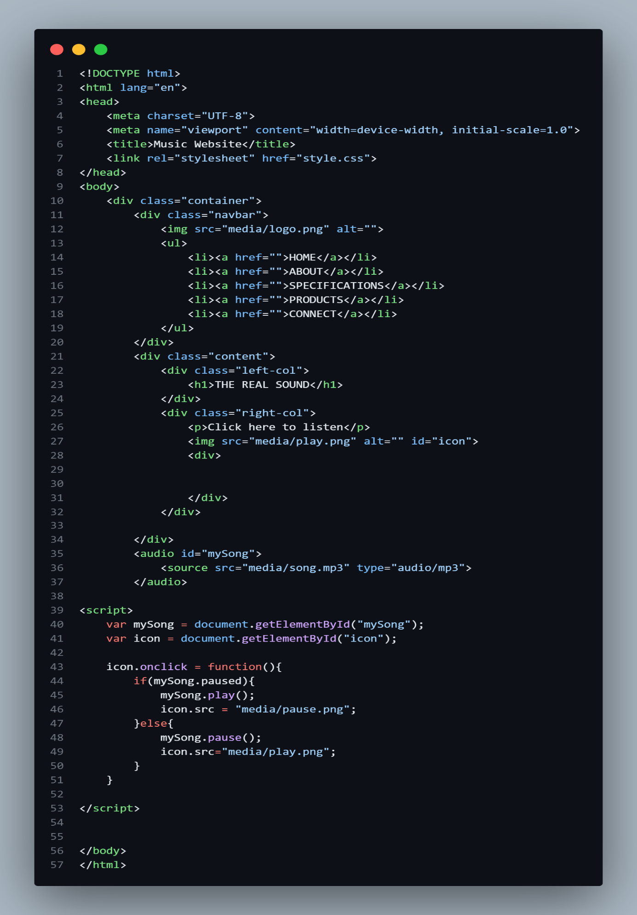

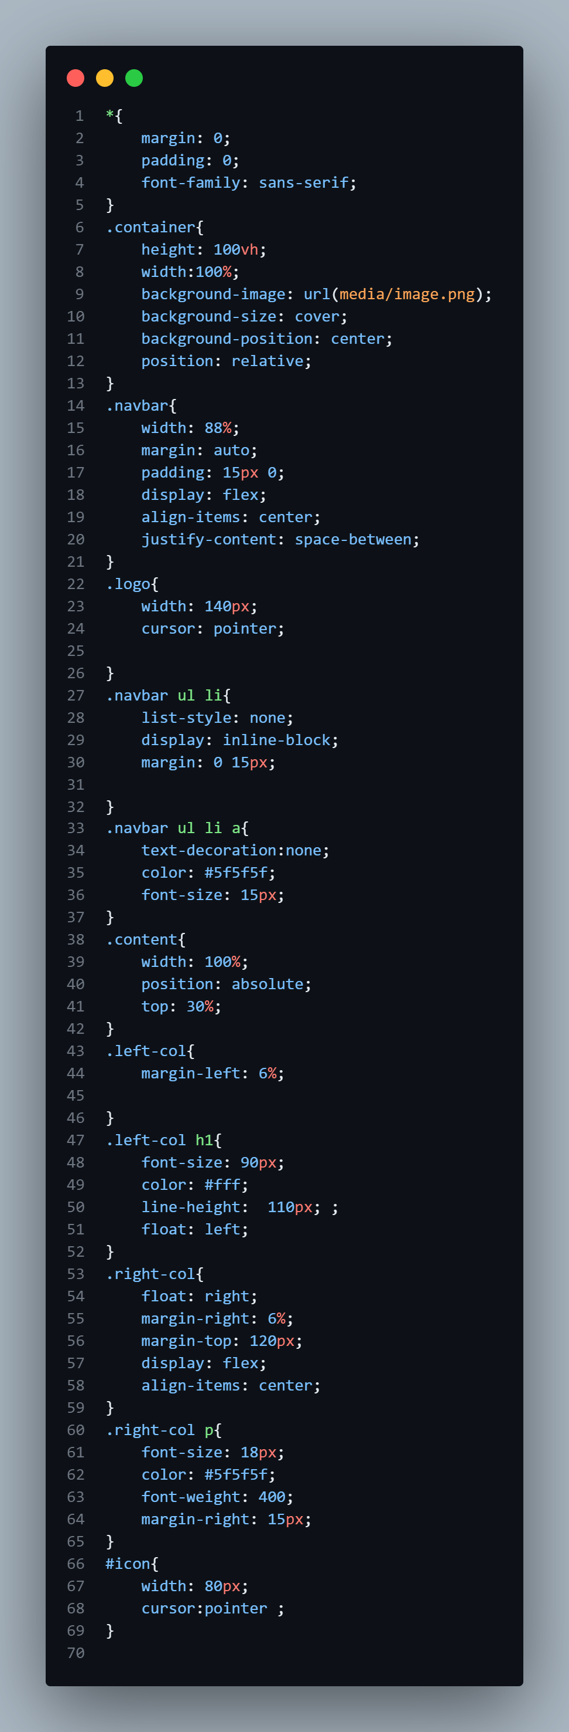





**Conclusion** :-

Mastering front end web development requires a solid understanding of HTML and CSS. By following best practices and using advanced techniques, you can create beautiful and responsive websites. Thank you for attending this presentation.

**Future Scope**:-

I will likely introduce playlist option in this music website and will also likely introduce more music in this music website.

Also will increase the more webpages for future updates in the music website

CHAPTER 5 CONCLUSION

5.1 Introduction:

In this chapter, we summarize the overall experience and insights gained from the

internship. This includes reflecting on the objectives achieved, the challenges

encountered, and the overall impact of the internship on professional and personal

development.

5.2 Lessons Learned and Skills Developed:

During the internship at Bussibees Ed-Tech Pvt. Ltd., I acquired valuable technical and

non-technical skills:

• Technical Skills:

- Gained proficiency in front-end technologies such as HTML, CSS, and JavaScript.

- Developed an understanding of responsive design, cross-browser compatibility, and

interactive features through hands-on experience.

- Improved problem-solving skills by addressing real-world issues during the

development process.

• Communication Skills:

- Enhanced ability to communicate technical concepts clearly and effectively with team

members and stakeholders.

- Learned to document work comprehensively and present progress updates in a

structured manner.

• Inter-Personal Skills:

- Strengthened teamwork and collaboration skills by working closely with other

developers and designers.

- Improved adaptability and flexibility in a fast-paced work environment, learning to

handle feedback and adjust to project requirements.

5.3 Limitations and Recommendations:

• Limitations:

- Limited exposure to advanced frameworks or back-end technologies due to the scope

of the internship.

- Time constraints restricted the ability to explore more complex features or conduct

extensive testing.

• Recommendations:

- Future internships could benefit from including exposure to a broader range of

technologies, such as modern front-end frameworks (e.g., React, Angular) or back-end

integration.

- Allocating time for deeper exploration of performance optimization techniques and

advanced coding practices could further enhance skill development.

REFERENCES

• https://getbootstrap.com/

• https://fontawesome.com/

• https://developer.mozilla.org/en-US/

• https://www.geeksforgeeks.org/

• https://www.w3schools.com/